**INTRODUCTION TO ARTIFICIAL INTELLIGENCE**

INTRODUCTION TO AI

In today's world, technology is growing very fast, and we are getting in touch with different new technologies day by day.

Here, one of the booming technologies of computer science is Artificial Intelligence which is ready to create a new revolution in the world by making intelligent machines.The Artificial Intelligence is now all around us. It is currently working with a variety of subfields, ranging from general to specific, such as self-driving cars, playing chess, proving theorems, playing music, Painting, etc.

Artificial Intelligence is composed of two words **Artificial** and **Intelligence**, where Artificial defines *"man-made,"* and intelligence defines *"thinking power"*, hence AI means *"a man-made thinking power."*

So, we can define AI as:

 "It is a branch of computer science by which we can create intelligent machines which can behave like a human, think like humans, and able to make decisions."

Artificial Intelligence exists when a machine can have human based skills such as learning, reasoning, and solving problems

With Artificial Intelligence you do not need to preprogram a machine to do some work, despite that you can create a machine with programmed algorithms which can work with own intelligence, and that is the awesomeness of AI.

It is believed that AI is not a new technology, and some people says that as per Greek myth, there were Mechanical men in early days which can work and behave like humans.

Why Artificial Intelligence?

Before Learning about Artificial Intelligence, we should know that what is the importance of AI and why should we learn it. Following are some main reasons to learn about AI:

* With the help of AI, you can create such software or devices which can solve real-world problems very easily and with accuracy such as health issues, marketing, traffic issues, etc.
* With the help of AI, you can create your personal virtual Assistant, such as Cortana, Google Assistant, Siri, etc.
* With the help of AI, you can build such Robots which can work in an environment where survival of humans can be at risk.
* AI opens a path for other new technologies, new devices, and new Opportunities.

**Goals of Artificial Intelligence**

Following are the main goals of Artificial Intelligence:

1. Replicate human intelligence
2. Solve Knowledge-intensive tasks
3. An intelligent connection of perception and action
4. Building a machine which can perform tasks that requires human intelligence such as:
   * Proving a theorem
   * Playing chess
   * Plan some surgical operation
   * Driving a car in traffic
5. Creating some system which can exhibit intelligent behavior, learn new things by itself, demonstrate, explain, and can advise to its user.

**What Comprises to Artificial Intelligence?**

Artificial Intelligence is not just a part of computer science even it's so vast and requires lots of other factors which can contribute to it. To create the AI first we should know that how intelligence is composed, so the Intelligence is an intangible part of our brain which is a combination of **Reasoning, learning, problem-solving perception, language understanding, etc**.

To achieve the above factors for a machine or software Artificial Intelligence requires the following discipline:

* Mathematics
* Biology
* Psychology
* Sociology
* Computer Science
* Neurons Study
* Statistics

## Advantages of Artificial IntelligenceIntroduction to AI

Following are some main advantages of Artificial Intelligence:

* **High Accuracy with less errors:** AI machines or systems are prone to less errors and high accuracy as it takes decisions as per pre-experience or information.
* **High-Speed:** AI systems can be of very high-speed and fast-decision making, because of that AI systems can beat a chess champion in the Chess game.
* **High reliability:** AI machines are highly reliable and can perform the same action multiple times with high accuracy.
* **Useful for risky areas:** AI machines can be helpful in situations such as defusing a bomb, exploring the ocean floor, where to employ a human can be risky.
* **Digital Assistant:** AI can be very useful to provide digital assistant to the users such as AI technology is currently used by various E-commerce websites to show the products as per customer requirement.
* **Useful as a public utility:** AI can be very useful for public utilities such as a self-driving car which can make our journey safer and hassle-free, facial recognition for security purpose, Natural language processing to communicate with the human in human-language, etc.

## Disadvantages of Artificial Intelligence

Every technology has some disadvantages, and thesame goes for Artificial intelligence. Being so advantageous technology still, it has some disadvantages which we need to keep in our mind while creating an AI system. Following are the disadvantages of AI:

* **High Cost:** The hardware and software requirement of AI is very costly as it requires lots of maintenance to meet current world requirements.
* **Can't think out of the box:** Even we are making smarter machines with AI, but still they cannot work out of the box, as the robot will only do that work for which they are trained, or programmed.
* **No feelings and emotions:** AI machines can be an outstanding performer, but still it does not have the feeling so it cannot make any kind of emotional attachment with human, and may sometime be harmful for users if the proper care is not taken.
* **Increase dependency on machines:** With the increment of technology, people are getting more dependent on devices and hence they are losing their mental capabilities.
* **No Original Creativity:** As humans are so creative and can imagine some new ideas but still AI machines cannot beat this power of human intelligence and cannot be creative and imaginative.

# Agents in Artificial Intelligence

An AI system can be defined as the study of the rational agent and its environment. The agents sense the environment through sensors and act on their environment through actuators. An AI agent can have mental properties such as knowledge, belief, intention, etc.

## What is an Agent?

An agent can be anything that perceiveits environment through sensors and act upon that environment through actuators. An Agent runs in the cycle of **perceiving**, **thinking**, and **acting**. An agent can be:

* **Human-Agent:** A human agent has eyes, ears, and other organs which work for sensors and hand, legs, vocal tract work for actuators.
* **Robotic Agent:** A robotic agent can have cameras, infrared range finder, NLP for sensors and various motors for actuators.
* **Software Agent:** Software agent can have keystrokes, file contents as sensory input and act on those inputs and display output on the screen.

Hence the world around us is full of agents such as thermostat, cellphone, camera, and even we are also agents.

Before moving forward, we should first know about sensors, effectors, and actuators.

**Sensor:** Sensor is a device which detects the change in the environment and sends the information to other electronic devices. An agent observes its environment through sensors.

**Actuators:** Actuators are the component of machines that converts energy into motion. The actuators are only responsible for moving and controlling a system. An actuator can be an electric motor, gears, rails, etc.

**Effectors:** Effectors are the devices which affect the environment. Effectors can be legs, wheels, arms, fingers, wings, fins, and display screen.

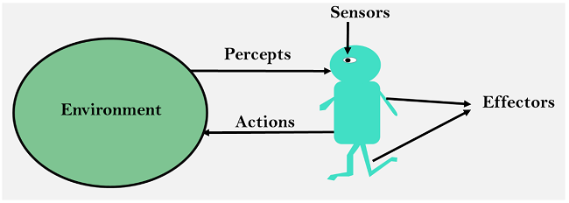

## Intelligent Agents:

An intelligent agent is an autonomous entity which act upon an environment using sensors and actuators for achieving goals. An intelligent agent may learn from the environment to achieve their goals. A thermostat is an example of an intelligent agent.

**Following are the main four rules for an AI agent:**

* **Rule 1:** An AI agent must have the ability to perceive the environment.
* **Rule 2:** The observation must be used to make decisions.
* **Rule 3:** Decision should result in an action.
* **Rule 4:** The action taken by an AI agent must be a rational action.

## Rational Agent:

A rational agent is an agent which has clear preference, models uncertainty, and acts in a way to maximize its performance measure with all possible actions.

A rational agent is said to perform the right things. AI is about creating rational agents to use for game theory and decision theory for various real-world scenarios.

For an AI agent, the rational action is most important because in AI reinforcement learning algorithm, for each best possible action, agent gets the positive reward and for each wrong action, an agent gets a negative reward.

### Rationality:

The rationality of an agent is measured by its performance measure. Rationality can be judged on the basis of following points:

* Performance measure which defines the success criterion.
* Agent prior knowledge of its environment.
* Best possible actions that an agent can perform.
* The sequence of percepts.

## Structure of an AI Agent

The task of AI is to design an agent program which implements the agent function. The structure of an intelligent agent is a combination of architecture and agent program. It can be viewed as:

1. Agent = Architecture + Agent program

Following are the main three terms involved in the structure of an AI agent:

**Architecture:** Architecture is machinery that an AI agent executes on.

**Agent Function:** Agent function is used to map a percept to an action.

### Problem-solving agents:

In Artificial Intelligence, Search techniques are universal problem-solving methods. **Rational agents** or **Problem-solving agents** in AI mostly used these search strategies or algorithms to solve a specific problem and provide the best result. Problem-solving agents are the goal-based agents and use atomic representation. In this topic, we will learn various problem-solving search algorithms.

## Search Algorithm Terminologies:

* **Search:** Searchingis a step by step procedure to solve a search-problem in a given search space. A search problem can have three main factors:
  1. **Search Space:** Search space represents a set of possible solutions, which a system may have.
  2. **Start State:** It is a state from where agent begins **the search**.
  3. **Goal test:** It is a function which observe the current state and returns whether the goal state is achieved or not.
* **Search tree:** A tree representation of search problem is called Search tree. The root of the search tree is the root node which is corresponding to the initial state.
* **Actions:** It gives the description of all the available actions to the agent.
* **Transition model:** A description of what each action do, can be represented as a transition model.
* **Path Cost:** It is a function which assigns a numeric cost to each path.
* **Solution:** It is an action sequence which leads from the start node to the goal node.
* **Optimal Solution:** If a solution has the lowest cost among all solutions.

## Properties of Search Algorithms:

Following are the four essential properties of search algorithms to compare the efficiency of these algorithms:

**Completeness:** A search algorithm is said to be complete if it guarantees to return a solution if at least any solution exists for any random input.

**Optimality:** If a solution found for an algorithm is guaranteed to be the best solution (lowest path cost) among all other solutions, then such a solution for is said to be an optimal solution.

**Time Complexity:** Time complexity is a measure of time for an algorithm to complete its task.

**Space Complexity:** It is the maximum storage space required at any point during the search, as the complexity of the problem.

## Types of search algorithms

**Based on the search problems we can classify the search algorithms into uninformed (Blind search) search and informed search (Heuristic search) algorithms.**

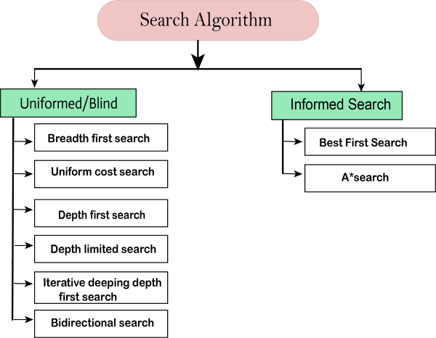

### Uninformed/Blind Search:

The uninformed search does not contain any domain knowledge such as closeness, the location of the goal. It operates in a brute-force way as it only includes information about how to traverse the tree and how to identify leaf and goal nodes. Uninformed search applies a way in which search tree is searched without any information about the search space like initial state operators and test for the goal, so it is also called blind search.It examines each node of the tree until it achieves the goal node.

**It can be divided into five main types:**

* Breadth-first search
* Uniform cost search
* Depth-first search
* Iterative deepening depth-first search
* Bidirectional Search

### Informed Search

Informed search algorithms use domain knowledge. In an informed search, problem information is available which can gauide the search. Informed search strategies can find a solution more efficiently than an uninformed search strategy. Informed search is also called a Heuristic search.

A heuristic is a way which might not always be guaranteed for best solutions but guaranteed to find a good solution in reasonable time.

Informed search can solve much complex problem which could not be solved in another way.

An example of informed search algorithms is a traveling salesman problem.

1. Greedy Search
2. A* Search

# Uninformed Search Algorithms

**Uninformed search is a class of general-purpose search algorithms which operates in brute force-way. Uninformed search algorithms do not have additional information about state or search space other than how to traverse the tree, so it is also called blind search.**

**Following are the various types of uninformed search algorithms:**

1. **Breadth-first Search**
2. **Depth-first Search**
3. **Depth-limited Search**
4. **Iterative deepening depth-first search**
5. **Uniform cost search**
6. **Bidirectional Search**

## 1. Breadth-first Search:

* Breadth-first search is the most common search strategy for traversing a tree or graph. This algorithm searches breadthwise in a tree or graph, so it is called breadth-first search.
* BFS algorithm starts searching from the root node of the tree and expands all successor node at the current level before moving to nodes of next level.
* The breadth-first search algorithm is an example of a general-graph search algorithm.
* Breadth-first search implemented using FIFO queue data structure.

**Advantages:**

* BFS will provide a solution if any solution exists.
* If there are more than one solutions for a given problem, then BFS will provide the minimal solution which requires the least number of steps.

**Disadvantages:**

* It requires lots of memory since each level of the tree must be saved into memory to expand the next level.
* BFS needs lots of time if the solution is far away from the root node.

### Example:

In the below tree structure, we have shown the traversing of the tree using BFS algorithm from the root node S to goal node K. BFS search algorithm traverse in layers, so it will follow the path which is shown by the dotted arrow, and the traversed path will be:

1. S---> A--->B---->C--->D---->G--->H--->E---->F---->I---->K

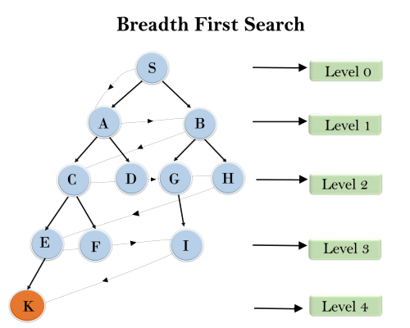

**Time Complexity:** Time Complexity of BFS algorithm can be obtained by the number of nodes traversed in BFS until the shallowest Node. Where the d= depth of shallowest solution and b is a node at every state.

**T (b) = 1+b2+b3+.......+ bd= O (bd)**

**Space Complexity:** Space complexity of BFS algorithm is given by the Memory size of frontier which is O(bd).

**Completeness:** BFS is complete, which means if the shallowest goal node is at some finite depth, then BFS will find a solution.

**Optimality:** BFS is optimal if path cost is a non-decreasing function of the depth of the node.

## 2.Depth-first Search

* Depth-first search isa recursive algorithm for traversing a tree or graph data structure.
* It is called the depth-first search because it starts from the root node and follows each path to its greatest depth node before moving to the next path.
* DFS uses a stack data structure for its implementation.
* The process of the DFS algorithm is similar to the BFS algorithm.

#### Note: Backtracking is an algorithm technique for finding all possible solutions using recursion.

**Advantage:**

* DFS requires very less memory as it only needs to store a stack of the nodes on the path from root node to the current node.
* It takes less time to reach to the goal node than BFS algorithm (if it traverses in the right path).

**Disadvantage:**

* There is the possibility that many states keep re-occurring, and there is no guarantee of finding the solution.
* DFS algorithm goes for deep down searching and sometime it may go to the infinite loop.

### Example:

In the below search tree, we have shown the flow of depth-first search, and it will follow the order as:

Root node--->Left node ----> right node.

It will start searching from root node S, and traverse A, then B, then D and E, after traversing E, it will backtrack the tree as E has no other successor and still goal node is not found. After backtracking it will traverse node C and then G, and here it will terminate as it found goal node.

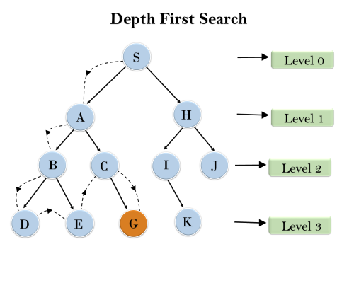

**Completeness:** DFS search algorithm is complete within finite state space as it will expand every node within a limited search tree.

**Time Complexity:** Time complexity of DFS will be equivalent to the node traversed by the algorithm. It is given by:

**T(n)= 1+ n2+ n3 +.........+ nm=O(nm)**

**Where, m= maximum depth of any node and this can be much larger than d (Shallowest solution depth)**

**Space Complexity:** DFS algorithm needs to store only single path from the root node, hence space complexity of DFS is equivalent to the size of the fringe set, which is **O(bm)**.

**Optimal:** DFS search algorithm is non-optimal, as it may generate a large number of steps or high cost to reach to the goal node.

# Hill Climbing Algorithm in Artificial Intelligence

* Hill climbing algorithm is a local search algorithm which continuously moves in the direction of increasing elevation/value to find the peak of the mountain or best solution to the problem. It terminates when it reaches a peak value where no neighbor has a higher value.
* Hill climbing algorithm is a technique which is used for optimizing the mathematical problems. One of the widely discussed examples of Hill climbing algorithm is Traveling-salesman Problem in which we need to minimize the distance traveled by the salesman.
* It is also called greedy local search as it only looks to its good immediate neighbor state and not beyond that.
* A node of hill climbing algorithm has two components which are state and value.
* Hill Climbing is mostly used when a good heuristic is available.
* In this algorithm, we don't need to maintain and handle the search tree or graph as it only keeps a single current state.

## Features of Hill Climbing:

Following are some main features of Hill Climbing Algorithm:

* **Generate and Test variant:** Hill Climbing is the variant of Generate and Test method. The Generate and Test method produce feedback which helps to decide which direction to move in the search space.
* **Greedy approach:** Hill-climbing algorithm search moves in the direction which optimizes the cost.
* **No backtracking:** It does not backtrack the search space, as it does not remember the previous states.

## State-space Diagram for Hill Climbing:

The state-space landscape is a graphical representation of the hill-climbing algorithm which is showing a graph between various states of algorithm and Objective function/Cost.

On Y-axis we have taken the function which can be an objective function or cost function, and state-space on the x-axis. If the function on Y-axis is cost then, the goal of search is to find the global minimum and local minimum. If the function of Y-axis is Objective function, then the goal of the search is to find the global maximum and local maximum.

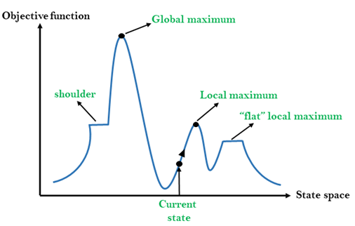

## Different regions in the state space landscape:

**Local Maximum:** Local maximum is a state which is better than its neighbor states, but there is also another state which is higher than it.

**Global Maximum:** Global maximum is the best possible state of state space landscape. It has the highest value of objective function.

**Current state:** It is a state in a landscape diagram where an agent is currently present.

**Flat local maximum:** It is a flat space in the landscape where all the neighbor states of current states have the same value.

**Shoulder:** It is a plateau region which has an uphill edge.

## Types of Hill Climbing Algorithm:

* Simple hill Climbing:
* Steepest-Ascent hill-climbing:
* Stochastic hill Climbing:

### 1. Simple Hill Climbing:

Simple hill climbing is the simplest way to implement a hill climbing algorithm. **It only evaluates the neighbor node state at a time and selects the first one which optimizes current cost and set it as a current state**. It only checks it's one successor state, and if it finds better than the current state, then move else be in the same state. This algorithm has the following features:

* Less time consuming
* Less optimal solution and the solution is not guaranteed

### Algorithm for Simple Hill Climbing:

* **Step 1:** Evaluate the initial state, if it is goal state then return success and Stop.
* **Step 2:** Loop Until a solution is found or there is no new operator left to apply.
* **Step 3:** Select and apply an operator to the current state.
* **Step 4:** Check new state:
  1. If it is goal state, then return success and quit.
  2. Else if it is better than the current state then assign new state as a current state.
  3. Else if not better than the current state, then return to step2.
* **Step 5:** Exit.

### 2. Steepest-Ascent hill climbing:

The steepest-Ascent algorithm is a variation of simple hill climbing algorithm. This algorithm examines all the neighboring nodes of the current state and selects one neighbor node which is closest to the goal state. This algorithm consumes more time as it searches for multiple neighbors.

### Algorithm for Steepest-Ascent hill climbing:

* **Step 1:** Evaluate the initial state, if it is goal state then return success and stop, else make current state as initial state.
* **Step 2:** Loop until a solution is found or the current state does not change.
  1. Let SUCC be a state such that any successor of the current state will be better than it.
  2. For each operator that applies to the current state:
     1. Apply the new operator and generate a new state.
     2. Evaluate the new state.
     3. If it is goal state, then return it and quit, else compare it to the SUCC.
     4. If it is better than SUCC, then set new state as SUCC.
     5. If the SUCC is better than the current state, then set current state to SUCC.
* **Step 5:** Exit.

### 3. Stochastic hill climbing:

Stochastic hill climbing does not examine for all its neighbor before moving. Rather, this search algorithm selects one neighbor node at random and decides whether to choose it as a current state or examine another state.

## Problems in Hill Climbing Algorithm:

**1. Local Maximum:** A local maximum is a peak state in the landscape which is better than each of its neighboring states, but there is another state also present which is higher than the local maximum.

**Solution:** Backtracking technique can be a solution of the local maximum in state space landscape. Create a list of the promising path so that the algorithm can backtrack the search space and explore other paths as well.

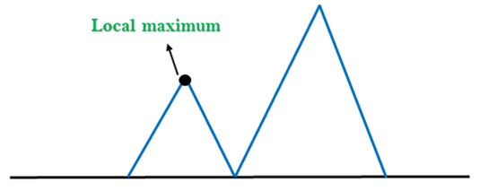

**2. Plateau:** A plateau is the flat area of the search space in which all the neighbor states of the current state contains the same value, because of this algorithm does not find any best direction to move. A hill-climbing search might be lost in the plateau area.

**Solution:** The solution for the plateau is to take big steps or very little steps while searching, to solve the problem. Randomly select a state which is far away from the current state so it is possible that the algorithm could find non-plateau region.

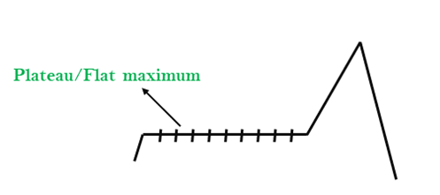

**3. Ridges:** A ridge is a special form of the local maximum. It has an area which is higher than its surrounding areas, but itself has a slope, and cannot be reached in a single move.

**Solution:** With the use of bidirectional search, or by moving in different directions, we can improve this problem.

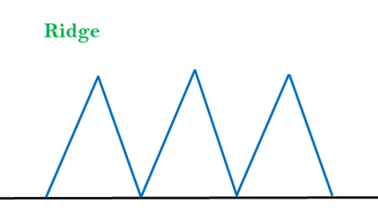

### Simulated Annealing:

A hill-climbing algorithm which never makes a move towards a lower value guaranteed to be incomplete because it can get stuck on a local maximum. And if algorithm applies a random walk, by moving a successor, then it may complete but not efficient. **Simulated Annealing** is an algorithm which yields both efficiency and completeness.

In mechanical term **Annealing** is a process of hardening a metal or glass to a high temperature then cooling gradually, so this allows the metal to reach a low-energy crystalline state. The same process is used in simulated annealing in which the algorithm picks a random move, instead of picking the best move. If the random move improves the state, then it follows the same path. Otherwise, the algorithm follows the path which has a probability of less than 1 or it moves downhill and chooses another path.

A local search is first conducted in the continuous space until a local optimum is reached. It then switches to a discrete space that represents a discretisation of the continuous model to find an improved solution from there.

In AI, local search involves solving problems with discrete states and actions using algorithms such as hill-climbing and simulated annealing. Local searches are widely used for optimisation tasks since they often require fewer computational resources than global searches, making them more efficient and cost effective.